|  |  |  |  |
| --- | --- | --- | --- |
| LAB 08 (chapter 6) Web Media  (with Photoshop)  |  | | --- | | What You Will Learn   * Some of the basic commands in Photoshop * How to save JPG, GIF, and PNG images * How to use the <video> and <audio> elements |  |  | | --- | | Approximate Time  The exercises in this lab should take approximately 30 minutes to complete. | |  | |
| Web Application Development  COP3834  Professor Navarro |

## Common Image Tasks

|  |
| --- |
| Preparing Directories |
| 1 | Download zip folder.. |
| 2 | Uncompress to your desktop. |
| 3 | This lab is going to also make use of a free icon font set called Sosa, which is available from http://tenbytwenty.com/?xxxx_posts=sosa/. You will need to download and install this font in order to complete the logo creation exercise. |

This feels like a virus webpage so we went to a secure one instead to download it

Photoshop is a complex image editor from Adobe. We will only be scratching the surface of this software in order to show you how to accomplish some typical web-related tasks. There is also a version of this lab using the free open-source GIMP image editor instead of Photoshop.

|  |
| --- |
| Exercise 6. — Image Formats |
| 1 | Start Photoshop and open the file british-museum.jpg. |
| 2 | Use the Zoom Tool and click repeatedly on the image until you reach the maximum zoom (1600%). Alt-click to unzoom. Double-click on the zoom tool to return to 100%. |
| 3 | Use the Crop Tool to keep just a part of the image (see Figure 6.1). When finished, double-click or press Enter.  The Crop tool allows you to select an area of an image and discard everything outside this area. |
| 4 | Press Ctrl-Z (or Command-Z on a Mac) to undo the last step. You can also use the Edit | Undo menu. |
| 5 | Press Ctrl-Z again to redo the crop. |
| 6 | Use the Eyedropper Tool and click in the image.  This changes the current foreground color to whatever color in the image that you sampled with the Eyedropper. The current foreground color is visible in the Set Foreground Color (see Figure 6.2). |
| 7 | Double-click on the current foreground color swatch (see Figure 6.2).  This will display the Color Picker. Notice that you can use this dialog to convert between different color models. |
| 8 | Close the image without saving it. |

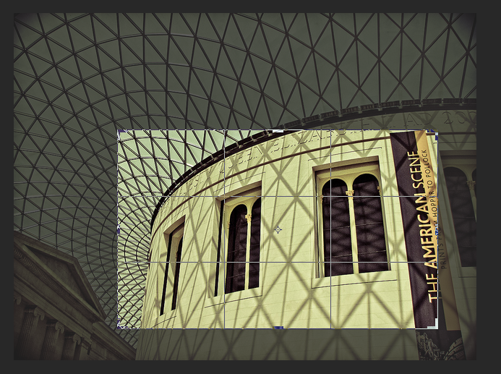

Figure 6.1 – Using the Crop Tool

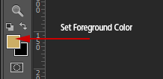

Figure 6.2 – Setting the Foreground Color

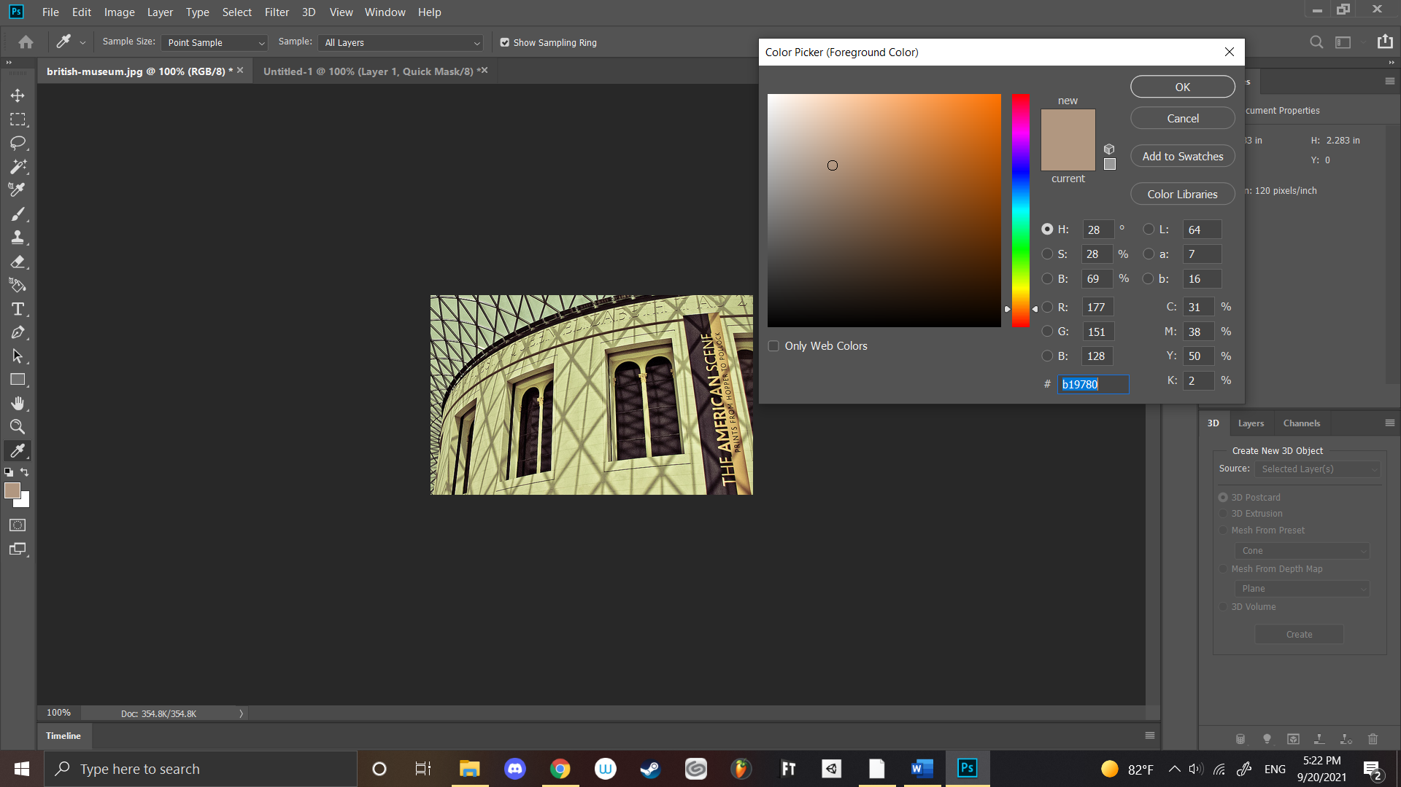

Showing work items from Exercise 6.1

|  |
| --- |
| Exercise 6. — Resizing Images |
| 1 | Open the file british-museum.jpg. |
| 2 | Use the Image | Image Size menu command.  This dialog allows you to resize an image by specifying a different width and height. |
| 3 | Toggle the Resample Image checkbox off and on.  When Resample Image is turned on, you can resize the image by adding (or removing) pixels from the image. When Resample is turned off, then you can only change the print size of the image (essentially by changing the print resolution). |
| 4 | With Resample Image turned on, change the width to 800 pixels then click ok.  Notice that modest increases in the size of a photographic image will not have especially adverse effects on the quality.  Has pretty much no effect on the image quality for this one |
| 5 | Press Ctrl-Z (or Command-Z on a mac) repeatedly to undo/redo the resizing. Compare the quality before and after the resizing. |
| 6 | Use the Image | Image Size menu command and resize the image to 100 pixels wide. Click Ok.  When you are decreasing the size of an image, the loss of quality is generally not as noticeable. |
| 7 | Close the image without saving. |
| 8 | Open the file british-museum-tiny.jpg. |
| 9 | Use the Image | Image Size menu command and resize the image by setting its width to 640 pixels. Click Ok.  Notice that the quality is now very poor. Thus making a large increase in the size of an image will result in a very poor image. See the below |
| 10 | Use the File | Revert menu command.  This shortcut is the equivalent of closing a file without saving and then reopening. |
| 11 | Use the Image | Canvas Size menu command.  This command lets you increase or decrease an image's canvas size. |
| 12 | In the Canvas Size dialog, change the width to 400 pixels, change the anchor to that shown in Figure 6.3 (this will add the pixels on the right side of the image) and then click Ok. |
| 13 | Close the image without saving. |

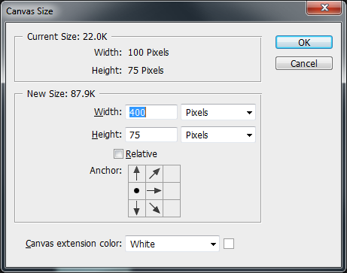

Figure 6.3 – Canvas Size dialog

|  |
| --- |
| Exercise 6. — Working with Vector Information |
| 1 | Open the file building-raster.jpg. |
| 2 | Use the Zoom Tool and click repeatedly on the image until you reach the maximum zoom (1600%). Alt-click to unzoom. Double-click on the zoom tool to return to 100%. |
| 3 | Close the file and then open building-vector.eps.  This is a vector-based file format, and Photoshop will raster this image when it opens it. |
| 4 | In the Rasterize EPS Format dialog, specify a width of 300 pixels and then click Ok.  Rasterizing is the process of turning vector information into pixels. |
| 5 | Use the Zoom Tool and zoom in the image.  Notice that it now consists of pixels. Notice as well the checkerboard pattern: this is Photoshop’s way of displaying transparent pixels. |
| 6 | Close the file then use the File | New menu command. In the New Dialog, set the width and height to 500 pixels then click Ok. |
| 7 | Use the File | Place **Embedded** menu command and select the file building-vector.eps. Click Ok.  This places the vector file as a vector object. This object can then be resized (or transformed in other ways). |
| 8 | The vector object is now displayed within a transform rectangle. Try dragging on the handles to resize the vector object. Holding down the shift key while dragging on a  corner handle will maintain the aspect ratio. You can rotate the object as well by dragging outside the transform rectangle. When finished, double click inside the rectangle. |
| 9 | Use the Zoom Tool and zoom in the image.  Notice that it now consists of pixels. |
| 10 | Examine the Layers windows (see Figure 6.4). Each layer in Photoshop can contain different information and can be manipulated independently of the other layers. You can click on the eye icon next to the layer name to toggle its visibility. |
| 11 | Use the Edit | Transform | Scale menu command. This will display the transform rectangle again. Make the building significantly larger. When done double-click. |
| 12 | Use the Zoom Tool and zoom in the image.  Notice that while the building still consists of pixels, Photoshop has resampled the original vector. |
| 13 | Use the Type Tool to add some text to the image. When you click in the image with the Text Tool, a type ribbon will be displayed just under the menu at the top of the window. This allows you to specify the font, the size, the color, and other options. Click the checkmark button when done.  Notice as well that a new layer has been created. You can now manipulate the text independently. |
| 14 | Select the Move Tool. This tool allows you to move pixels on the current layer (if Auto-Select check box is on, it will move whatever layer is directly below the mouse cursor). |
| 15 | Drag on the text you just entered to move it to a different part of the image. |
| 16 | Click on the building-vector layer in the Layers Window to make it the current layer. Then with the Move Tool still selected, drag the building to move it. |
| 17 | Use the File | Save As menu command. Save the file in Photoshop’s own file format and name it lab06-exercise03.psd. After saving it, close the file. |

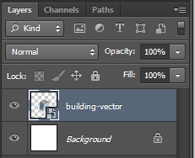

Figure 6.4 – Layers window

## Saving Web Images

|  |
| --- |
| Exercise 6. — Saving a JPEG |
| 1 | Open verona.tif.  A TIF file is a lossless raster file format. TIF files are often used as a way to move graphical information from one application to another with no loss of information. |
| 2 | Use the File | Export | Save for Web menu command.  This will display the Save for Web dialog. This dialog can be used to create JPG, GIF, and PNG files. It also allows you to preview the file thereby allowing you to easily experiment with different settings. |
| 3 | Within the Save for Web dialog, click on the 2-Up tab.  This will display both the original image and the optimized image (that is, the JPG/GIF/PNG version to be saved). |
| 4 | Click on the optimized image and then choose JPG from the drop down (see Figure 6.5). Experiment with the different quality settings. In the bottom left-hand corner of the dialog you can see the resulting file size.  You may need to use the Zoom button that is available within the dialog to best see the visual effect of the different settings. In Figure 6.5, notice the artifacts at the boundary between the land and the sky. |
| 5 | Click the Save button. Save the file as lab06-exercise04.jpg. |

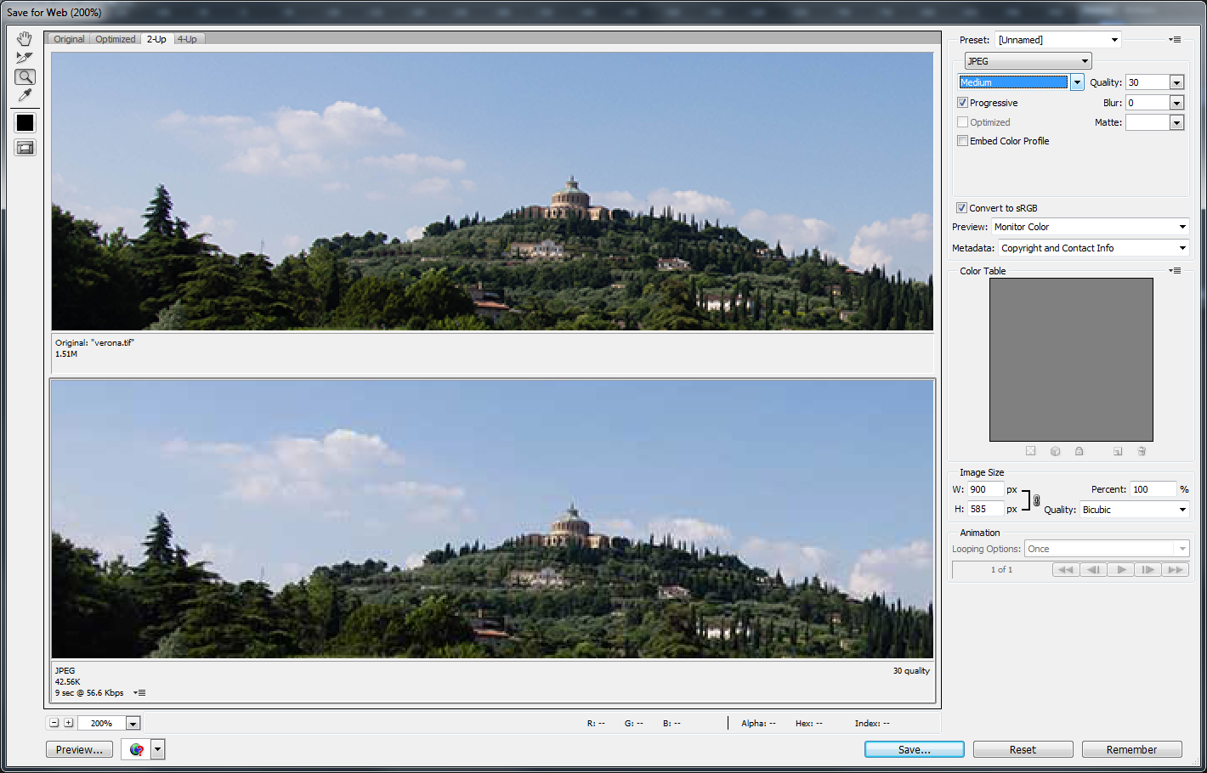

Figure 6.5 – Saving a JPG

|  |
| --- |
| Exercise 6. — Saving a GIF |
| 1 | Open CRM-logo.psd and examine its layers. |
| 2 | Turn off the visibility of the background layer. |
| 3 | Use the File | Save for Web menu command. |
| 4 | Within the Save for Web dialog, click on the 2-Up tab. |
| 5 | Click on the optimized image and then choose GIF from the type drop down. |
| 6 | From the GIF options, toggle the transparency checkbox off and on. |
| 7 | Experiment with the Colors drop-down list.  This changes the number of bits per pixel. Remember that in the bottom left-hand corner of the dialog you can see the resulting file size.  Changes amount of colors allowed in the image did 16 bit for fun. |
| 8 | When happy with the result, click the Save button. Save the file as lab06-exercise05.gif. |

|  |
| --- |
| Exercise 6. — Saving a PNG |
| 1 | Open building-transparency.psd and examine. |
| 2 | Use the File | Export | Save for Web menu command. Choose GIF from the type drop down. |
| 3 | From the GIF options, toggle the transparency checkbox on. |
| 4 | Click the save button and save the file as lab06-exercise06.gif. |
| 5 | Use the File | Export | Save for Web menu command again. |
| 6 | This time, choose PNG-24 as the file type. Ensure transparency is turned on. |
| 7 | Click the save button and save the file as lab06-exercise06.png. |
| 8 | View lab06-exercise06-tester.html in the browser. Notice the halo effects on the GIF due to the fact the GIF transparency is only 1-bit. |

Interestingly enough it has a slightly different rendering effect for my one on this.

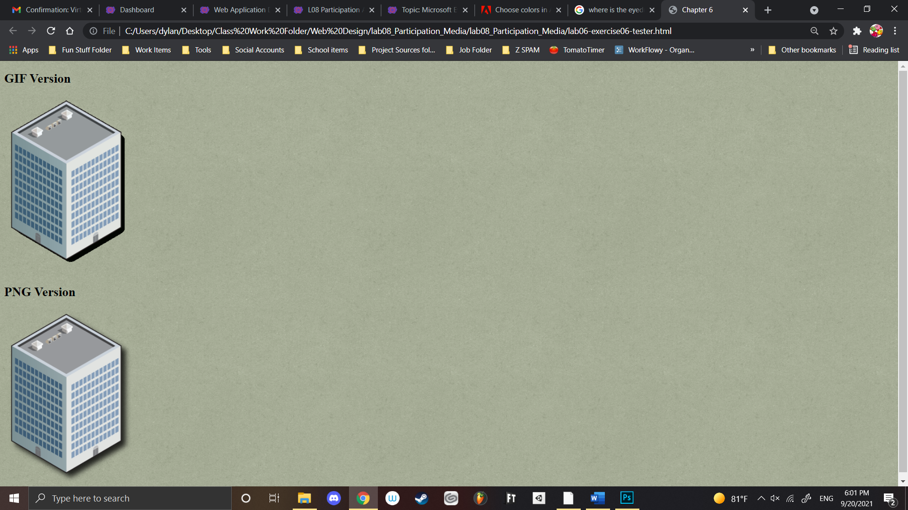

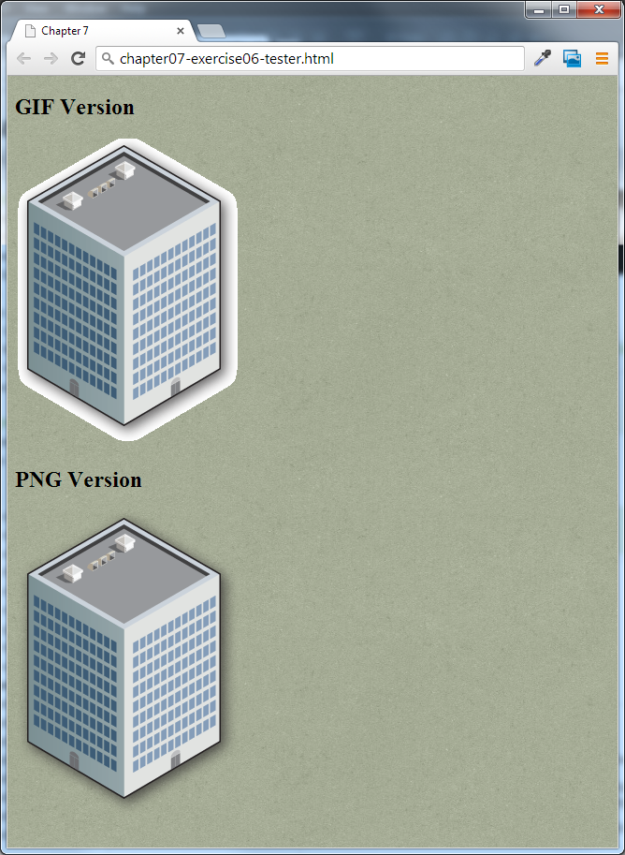

Figure 6.6 – Exercise 6.6 complete

|  |  |
| --- | --- |
| Exercise 6.b — compressing a jpg or png | |
| 1. Open british-museum.jpg in file explorer and examine. | |
| 1. Notice the file size and the resolution. | |
| 1. Upload the file to the site <https://tinyjpg.com/> | |
| 1. Download the newly created recompressed file. | |
| 1. What is the difference in size? ________320kb to 150kb_______________ 2. Is the quality usable? Looks pretty solid to me doesn’t seem to take away too much quality 3. Note that different png or jpg images will have different results. You may see greater data saving results from a png image | |
|  | |
|  | |

|  |
| --- |
| Exercise 6. — Creating a Logo |
| 1 | Create a new image in Photoshop using the File | New menu. |
| 2 | In the New dialog, set the width to 400 pixels and the height to 150 pixels. Click Ok. |
| 3 | Change the foreground color to ffffcc. Use the Edit | Fill menu command. From the Fill dialog , select Foreground Color in the Use drop-down list and then click Ok.  This should change the color of the entire background layer. There is also a keyboard shortcut for this step: alt-delete (or option-delete on Mac). |
| 4 | Select the Type Tool and click in the image. Change the font to Sosa (see note at beginning of lab about installing this font), the font size to 72, and the color to b0b5fd. |
| 5 | Click in the image and type in the text 1. Click the checkmark button when done.  If you are using the correct Sosa font, the number 1 will show up as a camera icon. |
| 6 | Select the Type Tool and click in an empty part of the image. Change the font to Times New Roman Bold, the font size to 60, and the color to 4f59df. Type in the text Share. Click the checkmark button when done. |
| 7 | Select the Type Tool and click in an empty part of the image. Change the font to Times New Roman, the font size to 48, and the color to 4f59df. Type in the text our Photos. Click the checkmark button when done. |
|  | Select the Type Tool and click in an empty part of the image. Change the font to Times New Roman, the font size to 48, and the color to 4f59df. Type in the text Y. Click the checkmark button when done. |
| 9 | Use the Move Tool, and the File | Transform menu command to position and rotate the elements as shown in Figure 6.7. |
| 10 | Save the file as lab06-exercise07.psd. |
| 11 | Use the File | Export | Save for Web command and save the file as a PNG. |



Figure 6.7 – Exercise 6.7 complete

## Working with Audio and Video

|  |
| --- |
| Exercise 6. — Video and Audio Elements |
| 1 | Open and examine lab06-exercise08-audio.html. |
| 2 | Add the following code and test.  <h2>mp3</h2>  <audio src="Sochi-Edit.mp3" controls >  Browser doesn't support the audio control  </audio> |
| 3 | Add the following code and test (ideally in IE and Chrome or Firefox).  <h2>ogg</h2>  <audio controls >  <source src="Sochi-Edit.ogg" >  <p>Browser doesn't support the audio control</p>  </audio>  At the time of writing, IE 10 does not support the Ogg audio format. Notice also that this step illustrates an alternative way of specifying the source. |
| 4 | Add the following code and test (ideally in Chrome or Firefox).  <h2>m4a</h2>  <audio controls >  <source src="Sochi-Edit.m4a" >  <p>Browser doesn't support the audio control</p>  </audio>  <h2>wav</h2>  <audio controls >  <source src="Sochi-Edit.wav" >  <p>Browser doesn't support the audio control</p>  </audio>  <h2>webm</h2>  <audio controls >  <source src="Sochi-Edit.webm" >  <p>Browser doesn't support the audio control</p>  </audio> |
| 5 | Add the following code and test.  <h2>All in one</h2>  <audio controls >  <source src="Sochi-Edit.mp3" type="audio/mpeg">  <source src="Sochi-Edit.ogg" type="audio/ogg">  <source src="Sochi-Edit.m4a" type="audio/mp4">  <source src="Sochi-Edit.wav" type="audio/wav">  <source src="Sochi-Edit.webm" type="audio/webm">  <p>Browser doesn't support the audio control</p>  </audio>  The browser will use the first source format that it supports. Notice also that MIME types are also defined.  It works!  It works! |
| 6 | Open and examine lab06-exercise08-video.html. |
| 7 | Add the following code and test (ideally in IE and Chrome and Firefox).  <h2>mp4</h2>  <video id="video" poster="video-preview.jpg" controls width="480"  height="360">  <source src="rocky.mp4"  type='video/mp4; codecs="avc1.42E01E, mp4a.40.2"'>  not supported  </video>  <h2>ogg</h2>  <video id="video" poster="video-preview.jpg" controls width="480"  height="360">  <source src="rocky.ogv" type='video/ogg; codecs="theora, vorbis"'>  not supported  </video>  <h2>WebM</h2>  <video id="video" poster="video-preview.jpg" controls width="480"  height="360">  <source src="rocky.webm" type='video/webm; codecs="vp8, vorbis"'>  not supported  </video> |
| 8 | Add the following code and test.  <h2>flash </h2>  <object type="application/x-shockwave-flash" data="rocky.swf" width="480"  height="360">  <param name="allowfullscreen" value="true">  <param name="allowscriptaccess" value="always">  <param name="flashvars" value="rocky.mp4">  </object>  ADOBE NOOOOOOOOOOOOOOOOOOOOOOOOOOOOO!!!!!!!!!!!!!!!!!!!!!!!!! RIP    To complete assignment answer the questions from Exercise 6.7b here and submit as a word or pdf doc:   1. What is the difference in size? ________320kb to 150kb_______________ 2. Is the quality usable? Looks pretty solid to me doesn’t seem to take away too much quality, while taking a decent bit of the data of so I would say so yes   Also answer:   1. Did you perform all of the steps of the lab (yes/no) yes sir! |